Exercise 4 – Report

Towards training a segmentation network with your own data

Eirik Fagerhaug and Novian Habibie

## Data Collection

We are using motion capture cameras and Cortex software to generate track map as polygons. Polygons captured by pointing using marker wand around the track segment, and save the points as one polygon. Rough polygon interpolated into more points to get smoother polygon. Polygons saved as .csv file.

Image captured using Basler camera that mounted into AudiCup car, then camera connected to the laptop that mounted in top of the car. Car also provided with motion capture marker to get its pose relative to the track. Data recorded with rosbag, a data recording tools from ROS, that record several informations:

1. Transformations (track base, marker wand, car/camera) as /tf topics
2. Image captured from camera (compressed) as /output/camera/compressed
3. Camera information (intrinsic matrix, etc) as /output/CameraInfo

## Code

Camera calibrated using Kalibr software, thanks to Johan Vertens for calibrating the camera.

Marker wand and car marker that captured by Cortex software connected to our PC by using Johan Vertens’ ROS code

Polygon capture system use our code **capture-poly.py**, by subscribing marker node published by motion capture system, and record the data by pressing buttons. We use <https://github.com/lrse/ros-keyboard> for button event program in ROS.

Polygon interpolation done using **carcapture2.py**, that subscribe to recorded data (in rosbag file). Output file saved as .png images.

## Results

This is some example results from different bagfiles:

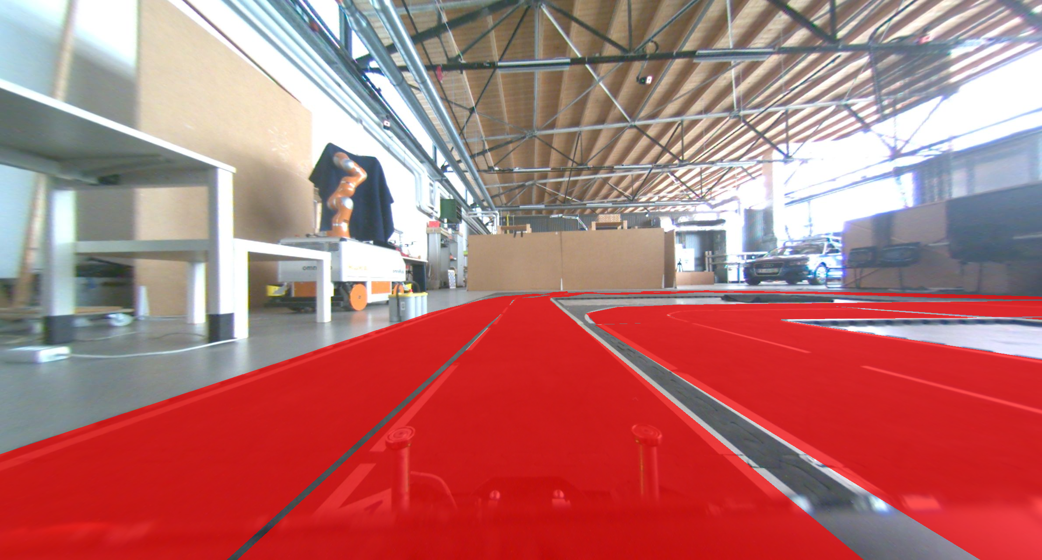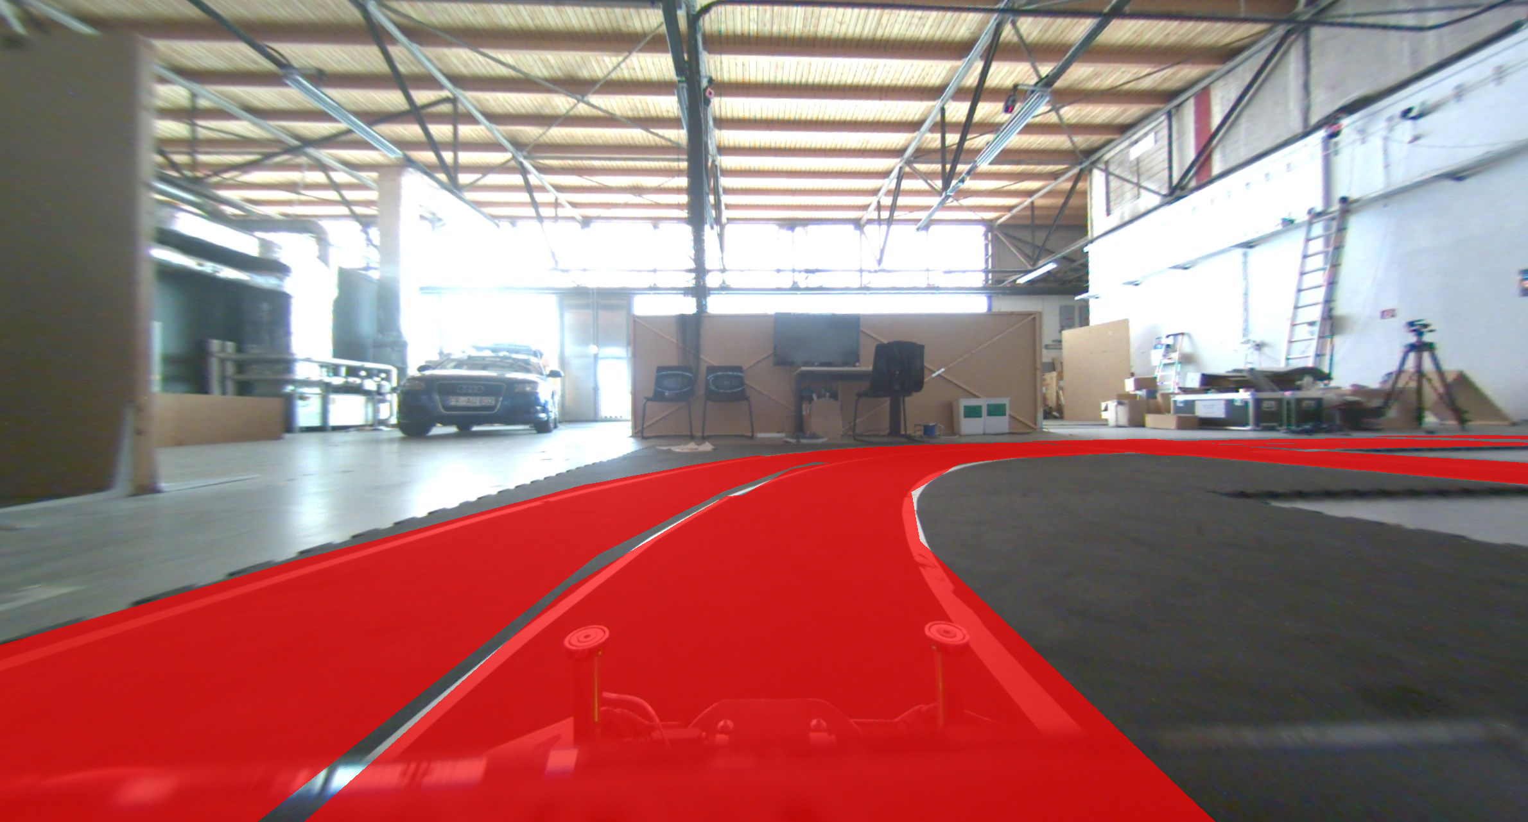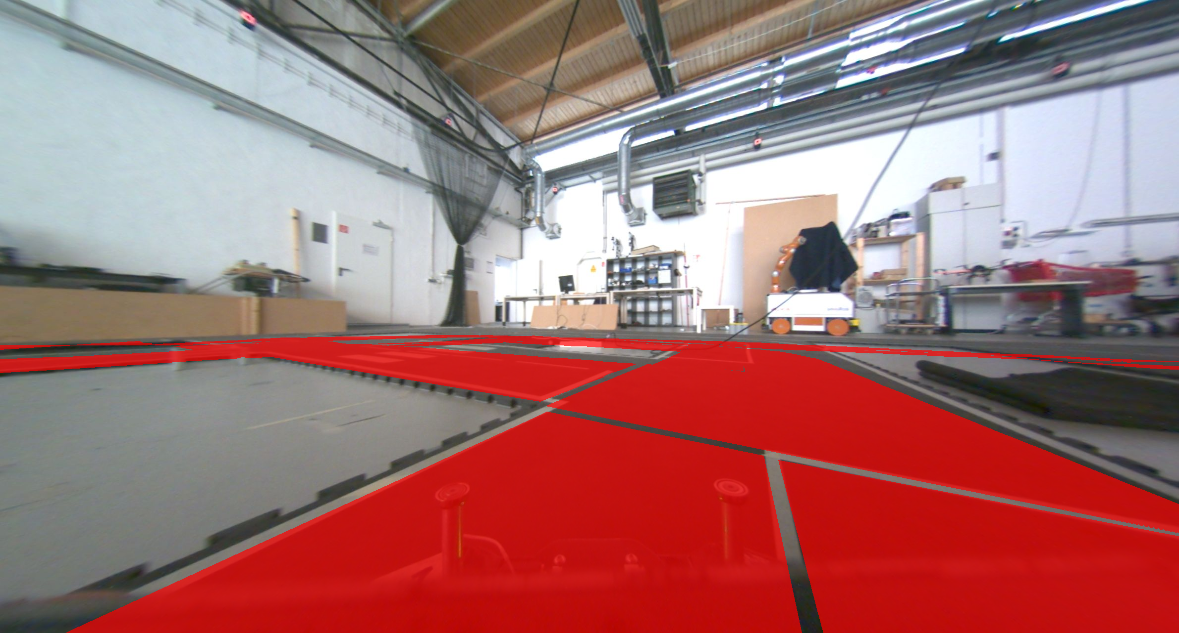

## 

## Discussion

Several image that captured cannot be annotated because sometimes marker is not detected so some image have no transformation data. We ignored images that have no pose.

Some polygons are slightly unaligned to the track. It might be caused by sudden acceleration or rough turn movement that makes a slight change to the car’s pose.